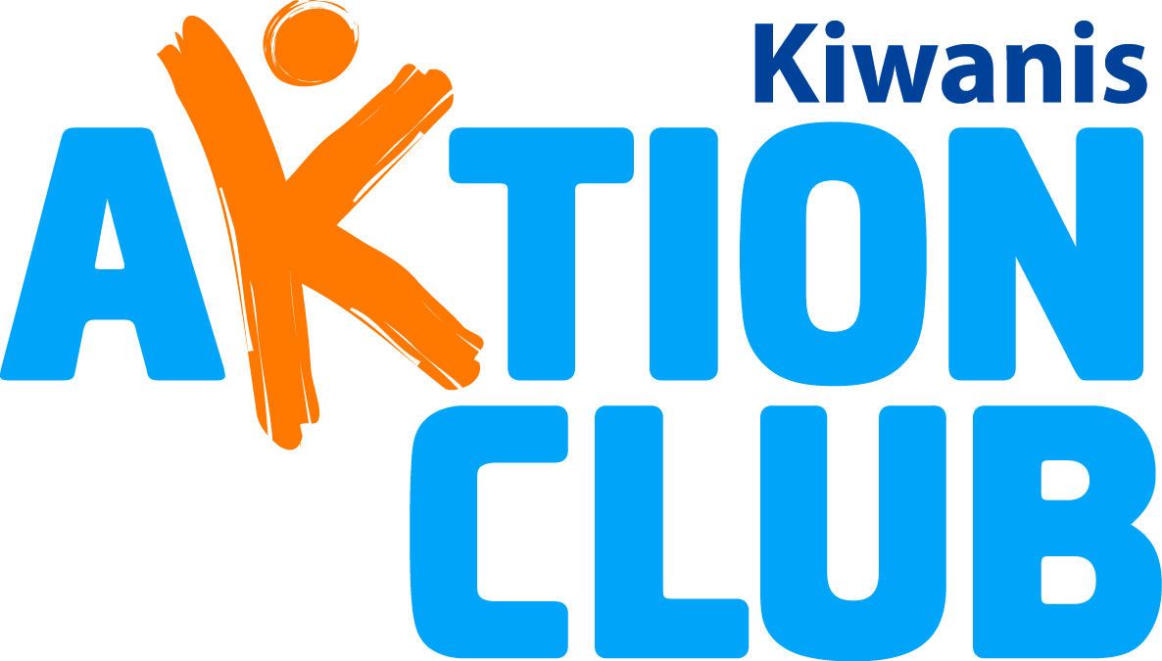

Michigan District Aktion Club 2018 Convention
Rock Lake Christian Assembly Camp
Vestaburg, Michigan
September 14-15, 2018
Aktion Clubs Show Olympic Spirit

“The most important thing in the Olympic game is not in winning but in taking part; the essential thing in life is not conquering but fighting well.”
Pierre de Coubertin, Founder of the Modern Olympic Games

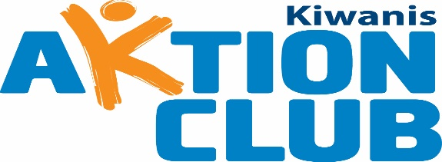

Annual Aktion Club Convention
Rock Lake Christian Assembly Camp, Vestaburg, Michigan
September 14-15, 2018

REGISTRATION: We are happy to invite Aktion Club members and Advisors to the 2018 Annual Aktion Club District Convention. This year’s convention promises education, inspiration, and fellowship opportunities for all. Clubs members will have fun participating in Olympic Contests during the convention. The Host Committee is looking forward to seeing many old and new faces at the convention.
Our theme for the convention is: Aktion Clubs Show Olympic Spirit.
Enclosed are all the camp registration forms. Please print off and fill the forms out as directed. Any questions can be directed to Susan Devon: susancdevon@gmail.com or call her at 517-331-6256.
Aktion Club Member of the Year Nomination Form: Each club should nominate a member from their own club whom they feel is deserving of this honor. Please return the Nomination Form with your registration papers. If you do an on-line registration, please mail your nominations to Sue Devon at the address below. Each nominee will be recognized during the awards ceremony at this year’s convention.
Photo Release: Each individual Aktion Club member attending the convention must complete this form. This will remain valid for one year and will be kept in the care of the Aktion Club District Administrator.
2018/2019 Governor and Governor Elect: Aktion Club members wishing to run for the positions of Aktion Club District Governor and Governor Elect positions should come prepared with their speech. Speeches should be limited to 3 minutes, so plan accordingly. Campaign poster are encouraged, but not required.
Advisors Needed for Activities: All Club Advisors, we need your help. There are various Olympic Games and many other activities that will take place on Friday and Saturday. Please indicate on the registration form if you are willing to assist.

RETURN ALL REGISTRATION FORMS TO THE FOLLOWING ADDRESS:
Susan Devon
16793 Printemp Drive
East Lansing, MI 48823

Host Committee:
Registration Committee: Susan Devon; susancdevon@gmail.com
Program Committee: Susie Grizzle; SusieGrizzle@outlook.com
Service Project: Brook Lippert; blippert@peckham.org
Food Committee: Sidney Lounds; Sidlounds4@gmail.com
Welcoming Committee: Gordon Schleicher; gschleicher1@wowway.com
Awards Committee: Marcy Waller; mjenwal@yahoo.com
Ed Buday; budaysr@sbcglobal.net
Jeanette Harris; jharris48@yahooo.com

Motto: Where development has no disability

Vision: To develop competent, capable, caring leaders through the vehicle of service
Mission: To provide adults living with disabilities an opportunity to develop initiative, leadership skills and to serve their communities

Kiwanis International Aktion Club Contests:
As in past years the Michigan District clubs will also be working on the speech and poster contests. This year, two new contests have been added to Aktion Club’s international contest program: a video contest and a social media contest. The theme for the year is, ABILITY IN AKTION. For the video contest, each club that enters will need to create a two-minute promotional video that shows its particular ABILITY IN AKTION. This can include clips from service projects, fundraisers, social events and Kiwanis-family events — as well as snippets of members, advisors and others sharing information on the club, club activities and club membership. The social media contest will focus on your club’s presence on all social media outlets related to club service projects, fundraising, social events, advocacy, leadership and Kiwanis-family events. The quality and quantity of posts will be judged as well. General direction for the various contests are:
Speech: Discuss how you displayed your ABILITY IN AKTION with Aktion Club this year. Give examples of how Aktion Club helped you improve your ability to make a difference in your community. Speeches must be video recorded and emailed to Susan Devon at susancdevon@ gmail.com by August 31, 2018
Poster: Draw a picture of you or your club showing your ABILITIES IN AKTION. The posters will be created at the convention. Each club should bring supplies to work on their posters.
Single Service: With fellow club members, tell about a service project where you showed your ABILITIES IN AKTION with your community service.
Scrapbook: With fellow club members, create a scrapbook showing your club’s ABILITY IN AKTION through the events, service and fundraisers of your Aktion Club year. Clubs should bring their completed scrapbooks and entry form to the convention for judging.
Video: Take a short (2 minute) video showing your club’s ABILITY IN AKTION. Clubs should bring their completed Video and entry form to the convention for judging.
Social Media: Share how you showed your ABILITY IN AKTION on social media this year.

Clubs should bring their completed scrapbooks and entry form to the convention for judging. If your club cannot attend the convention but wished to participate in the contests mail or email your entries to Susan Devon by August 31:
Susan Devon
16793 Printemp Drive
East Lansing, Michigan 48823
susancdevon@gmail.com

Remember to check specific guidelines for each contest in the contest booklet online: http://www.aktionclub.org/Libraries/Contests_and_Awards/Contest_Booklet-2015-16.sflb.ashx
All entries will be judged and winners announced at the convention. The District Administrator will submit the winning entries to Kiwanis International by September 30th.

