Larry Memmer from the Kiwanis Club of Chelsea
Announces Candidacy for Governor-Elect 2017-2018
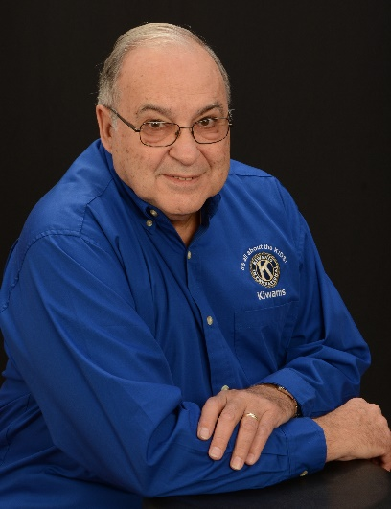
My name is Larry Memmer, currently a member of the Kiwanis Club of Chelsea. I would like to announce that I am running for Governor-Elect for 2017-2018. Running for Governor-Elect is something I have considered for awhile. Being retired, I feel I have the time necessary to devote to the Kiwanis family. Some of my non-Kiwanis friends think I spend way too much time with Kiwanis activities. My answer, it is easy to work for an organization when you believe in its 6 objectives, and have a passion for the organization! I am prepared to work hard for Kiwanis and try to be available to help your club, when needed.
My journey with Kiwanis stated in 1980, when I joined the Kiwanis Club of Grand Rapids North. I was an active member of the club for five years. My job moved me to Alma, Mi in 1985. Unfortunately, the next 23 years I wasn’t a Kiwanian.
In 2008 I retired, and my wife, Nancy, and I moved to Howell, Mi. I joined the Kiwanis Club of Brighton.
I felt Kiwanis was a good fit for me; I enjoyed working with other Kiwanians, doing service projects in the community, and helping children in the district. When Howell opened a Kiwanis Club in 2009, I was a charter member. I continued to have dual membership in the 2 clubs until we moved to Grass Lake Mi. in the summer of 2016. During the 8 years in Howell and Brighton, I helped start a Builders club in Howell, and an Aktion club in Brighton. I worked on many service projects with both clubs, was Secretary of both clubs, and Treasurer of the Brighton club. I served as Lt. Governor for Division 9 for 2 years, and was an International Distinguished Lt. Gov in 2011-2012. I am a master Kiwanis trainer, and have facilitated training workshops for the Club Leadership Education and Fall Leadership Education.

Many of you know me as the District Membership Formula Chairman for the district. I have had this position since March of 2015, and have helped facilitate 6 club openings. Maintaining memberships in existing clubs, and opening new clubs is a major focus of both Kiwanis International, and the Michigan District. I am excited to see what we have accomplished, and know we will continue to use the Formula to increase membership in the years ahead. During those 2 years, I was fortunate enough to be invited to many of the clubs throughout Michigan to speak about the Formula. If elected Governor-elect, I would like to continue to visit clubs and meet the members. As a former businessman, and project manager, I feel that personal contact with members of clubs helps to make us all more invested in the Kiwanis organization.
Since I rejoined Kiwanis in 2008, I have watched the Governors of Michigan: I have seen new policies, good leadership, development of strong committees, and good strategic planning for the future. Kiwanis in Michigan is strong, and continuing to be stronger every year. As Governor-Elect, I would like to continue the work the governors before me have accomplished. I would like to encourage clubs to increase their service to their communities, and the youth. Together, we can continue to make Kiwanis of Michigan even stronger. I hope you will support me in my next chapter of Kiwanis life.
Larry Memmer

