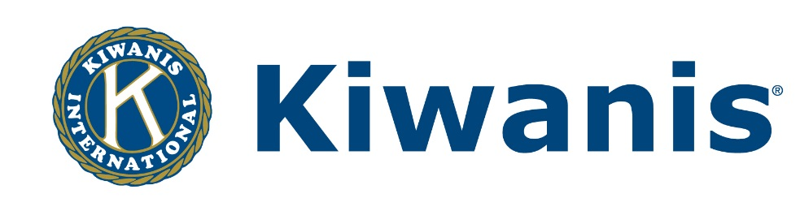

Louisiana-Mississippi-West Tennessee District

THE 2014-2015 DISTRICT FUND-RAISING CONTEST
Governor John McCay is encouraging all clubs to share the information on their Fund-Raising Projects with other Kiwanis Clubs in the District, by participating in the 2014-2015 La.-Miss.-W.Tenn. District Fund-Raising Contest. In this new contest for the 2014-2015 Kiwanis Year, clubs are invited to participate in the
- Annual Fund-Raiser Contest – in either the Single Fund-Raiser Category (for those clubs with one single fund-raising project) or the Multiple Fund-Raiser Category (for the clubs with more than one fund-raising project).
Awards: Banner Patch Awards in both categories, for one Winner and up to 2 Honorable Mentions in each of the sections: Diamond Section (clubs with 76 or more members), Ruby Section (46 to 75 members); Emerald Section (30 to 45 members); and Coral Section (fewer than 30 members).

- Most Original Fund-Raiser Contest – if you feel that your club has a unique Fund-Raising Project that you wish to brag about.
Awards: Banner Patch Awards for one Winner and up to 2 Honorable Mentions for the Most Original Fund-Raising ideas in the District.
Each participating club will be asked to describe the project(s), provide the total amount raised and the net profit raised through each project. Contest entry forms will be developed and made available to all clubs in the District. Photos and newspaper clippings (if any are available), may be submitted along with the contest entry form.
For additional information on Fund-Raising, contact Stephanie Crow, District Chair on Fund-Raising, at 318/934-3466, or by e-mail at gymnast92685@aol.com.

