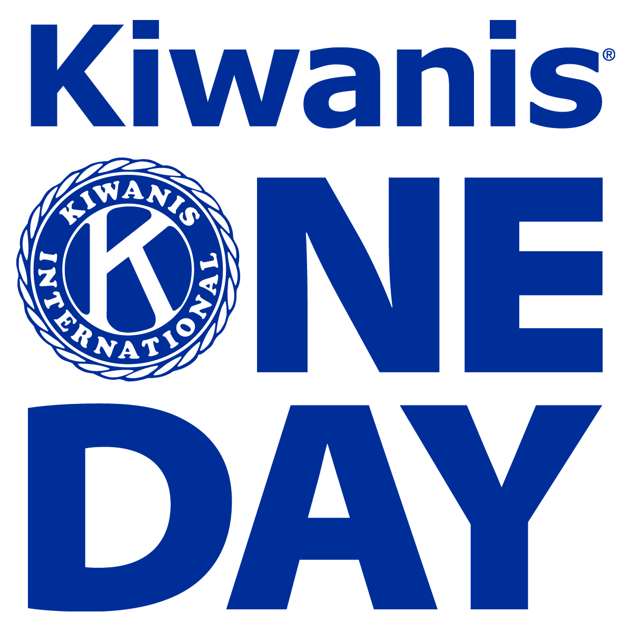

You’re invited to a fun-filled Kiwanis event!

Region 5 Kiwanis One Day
At
Lake Waccamaw Boys & Girls Home
400 Flemington Drive
Lake Waccamaw, NC 28450
On
Saturday, October 28, 2017
9 AM – 2 PM
(Registration begins at 8:30 AM)

We’ll hear from Kiwanis leaders and student Kiwanians, participate in a club strengthening activity, tour the home, complete a service project, share in a Fall activity with children of the home and enjoy lunch together.

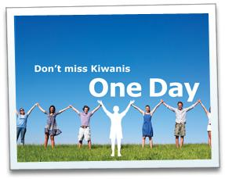

RSVP by Friday, October 20, 2017 to your Lt. Governor!

Let’s show Kiwanis cares by donating personal care items for teens and/or baby care items to the Lake Waccamaw Boys & Girls Home.

