The poop deck

Pilot Club of Odessa

PO Box 4042
Odessa, TX 79760
pcodessa@outlook.com

A Message from our President
2017 – 2018 Officers
President
Mary Blain

President-Elect
Ruben Rodriguez

Recording Secretary
Carla Bryant

Corresponding Secretary
Sheryl Jones

Treasurer
Frances Irvine

Director
Loretta Leslie

Leadership
Jannee Banner

Fundraising
Yolanda Sanchez/Omega Loera

Membership
Mary McClelland/Sue Kettle

Projects
Karen Hopkins/
Carrie Fambrough

Anchor
Linda Pruden/Maria Sanchez
My dearest Pilot friends,
We face challenges and we always find solutions. That is the spirit I see in our Pilot Club with everything we do. We work so diligently that sometimes we forget to have fun. I invite you to see our gatherings as a fun time to spend with some of your fellow Pilot
friends to get to know them and to make new friends. I invite you to feel and seek what Connie Hernandez our Pilot Texas Governor is telling us to do “Bringing the JOY of Pilot”.

friends to get to know them and to make new friends
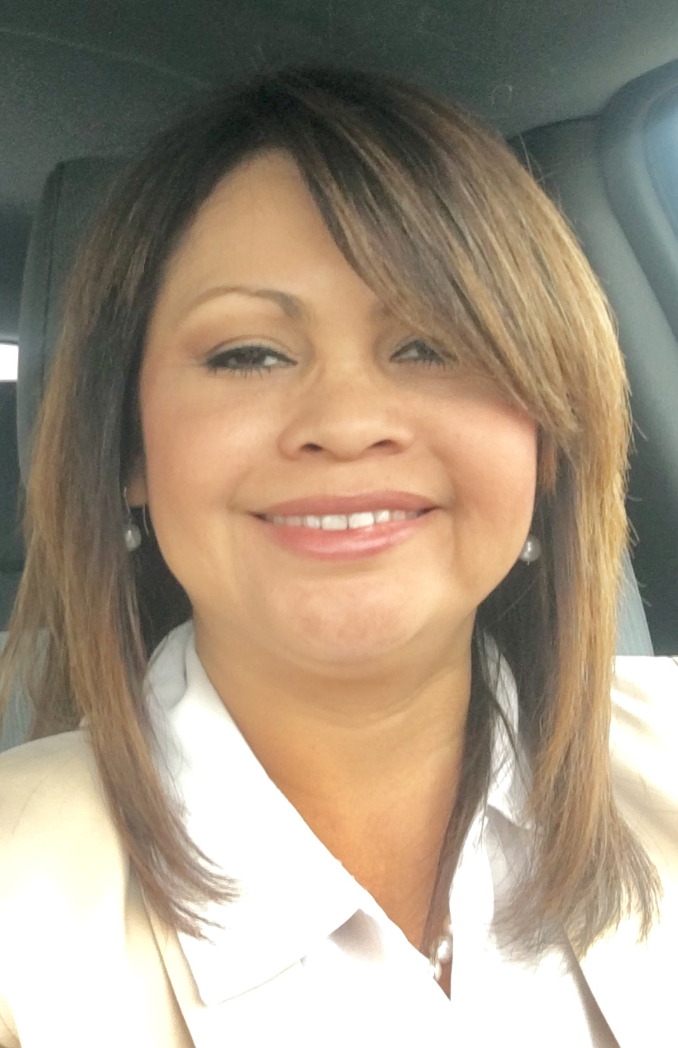
Let’s continue mentoring and nurturing new Pilots. Let’s invite a friend so we can continue growing.
At the Pilot International Convention in Las Vegas, Nevada, in one of our general sessions, I asked one of our Texas representatives if I could sit with them at their table. The lady hesitated and did not answer. I told her that I understood and I moved away. That didn’t hurt my feelings. I simply understood the lady was burned out; she did not want to make new friends. I am sure she is an excellent person and a great Pilot but sometimes our life situations make us do and act differently. I cannot change that person’s attitude, I can only change mine; so, I decided to sit in another table and guess what?... I made new friends and I had fun.
At convention, I learned many wonderful things that I am taking as tools to sharpen my leadership skills and to promote more leaders within our club. We had three wonderful speakers. We witnessed in what and how our Anchors worked together. We participated in a community project. We did not know each other but we worked as we depended on each other. What a wonderful team effort it was to witness the beauty of Pilot International gathering.
It was an honor to represent Pilot Club of Odessa at Pilot International. It is always nice and exciting meeting new people and places. Thank you, Carla Bryant and Ann Volker for introducing me to many of your friends. Thank you, Pilot Club for allowing me to be in Vegas.
Our Club is currently meeting at First United Methodist Church Odessa thanks to the generosity of Rev. Karin Carlson and Rev. Todd Salzwedel. We will continue meeting there for the rest of the year 2017.
We are ready to start our 2017-2018 year. Our new Executive Board was installed and our budget and Plan of Works were approved.
Let’s start our year with a positive attitude, with a renewed mind and a refresh spirit. As PI stays, let’s help to: Do more. Care more. Be more.
Thank you, Mary

Mary

.
.

IMPORTANT DATES FOR JULY

PI Convention—July 6-9

Business Meeting – July 12th

Meals on Wheels –July 21st

Program Meeting—July 26th

JULY PILOT ANNIVERSARIES

Sheryl Jones 1 year
Omega Loera 3 years
Ruben Rodriguez 3 years
Susan Thornton 3 years

CODE OF ETHICS - PILOT CLUB INTERNATIONAL
Realizing that whatever a Pilot touches should be ennobled by that touch, we, as business leaders, are resolved to make our business standards high, to do our work in every place in which we are employed as if it were our life work, never omitting an opportunity of doing a kindness or making a friend; to put into our business dealings a note of sympathy for humanity; to follow truth; to do our best from dawn till night; and so to live in the discharge of our duty, so to take care of every responsibility that comes before us that we shall radiate that which is unselfish, beautiful and true; and when we shall have finished with our tasks we shall have given an upward impetus to human ideals and achievements.

Susan Thornton 7/1
Stephanie Latimer 7/3
Barbara Benefield 7/6
Pat Johnson 7/7
Alma Huerta 7/26
Mary Blain 7/30

Fundraising Division
We have a possible fundraising opportunity to sell pecans at the Farmer’s Market on
Saturday, August 19th. The Farmer’s Market will be held near the old Bronco Chevrolet building, and is located at the corner of 3rd and Alleghaney. We need Pilots to sign up for a 2-hour shift from 7:00 am – 9:00 am, 9:00 am – 11:00 am, or 11:00 am – 1:00 pm. The actual hours the Farmer’s Market is open to the public is from 8:00 am – 12:00 pm, but we need help with set-up and take-down. If you are available to help, please call Beverly Landgraf at 550-5713, or email her at beverlylandgraf@gmail.com

Projects Division

Meals on Wheels: Thank you to drivers for June: Marge Garner, Sherry Tuttle, Kristy Infiesto and Carrie Fambrough. Drivers for July are: Marge Garner, Mary Blain and Lupe Baiza.

We are looking for someone to chair Fall Fest/Hard Hats for Little Heads. Please let Karen Hopkins or Carrie Fambrough know if you are interested in chairing that event.

Membership Division

Share Pilot will be held for our August program meeting (8/23), and we need names of potential members!! If you have friends who might be interested in joining the Pilot Club, please email Pat Johnson their name, address, phone # and email address. Pat’s email is patjohnson7@att.net

Membership changes: Resignations—Julie Anderson, Bes Castleman, Adina Crain, Jean Gorrell, Ariel Renteria and Linda Terrell. Kathy Schlegel changed to an active restricted member.

Good news!! Artie Everett was approved for a kidney transplant!! Please continue to pray for a compatible donor!

If any of you have a prayer request for yourself or a family member, please let Sue Kettle, Mary McClelland or Jane Triplett know.

For corrections or if you would like to contribute an article, report, photo (including caption), new, or anything related to our club, please email Editor: Mary McClelland at macnblack@att.net for submission.

July Program Meeting-Check Presentations
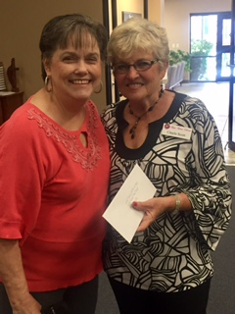
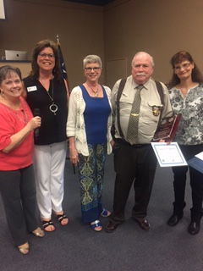
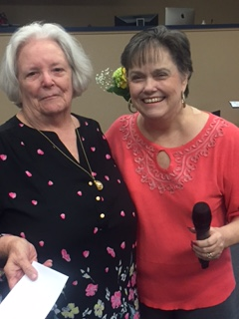
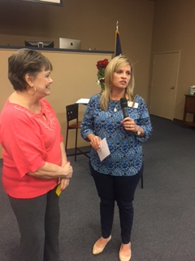

Left to right: Kim Ortega accepted a check for $1,800 for the PBRC, Sergeant David Jones with the ECSO & Debbie Bruce, reserve deputy, received a check for $1,800 for Project Lifesaver, Margaret Burton was pleased to accept a check for $5,500 for Meals on Wheels, Charle Scott accepted a check for $750.00 for the Look Good/Feel Good shop

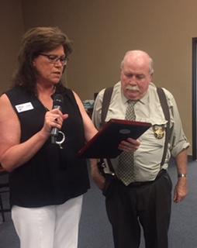
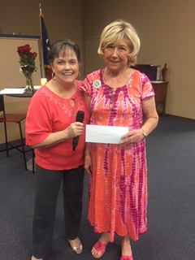
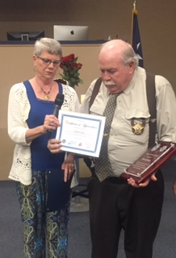

Left to right: Loretta Leslie accepted a check in the amount of $1,000 for MCH Friendship Home, Lynn Van Amburgh presented Sergeant Jones with a plaque to show our appreciation for his years of service in Project Lifesaver since its inception, Carla Bryant presented him with a certificate making him an honorary Pilot

July Program Meeting-Installation of Officers

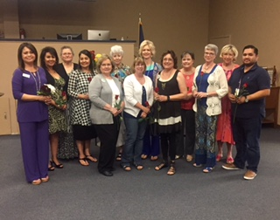
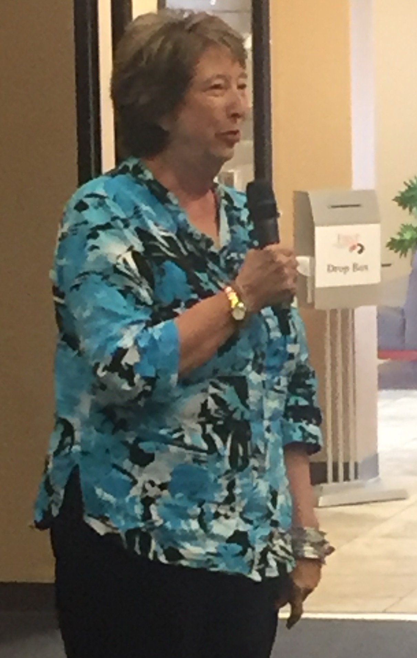

Left to right: Ann Volker did an amazing job on the Installation Ceremony. Mary Blain, President; Yolanda Sanchez, Co-Director of Fundraising; Sheryl Jones, Corresponding Secretary; Omega Loera, Co-Director of Fundraising; Frances Irvine, Treasurer; Sue Kettle, Co-Director of Membership; Carrie Fambrough, Co-Director of Projects; Mary McClelland, Co-Director of Membership; Linda Pruden, Co-Director of Anchor; Janee Banner, Director, Leadership; Carla Bryant, Recording Secretary; Loretta Leslie, Director, Attendance; Ruben Rodriguez, President Elect. Not pictured: Karen Hopkins, Co-Director of Projects; Maria Sanchez, Co-Director of Anchor.

Pilot International Convention
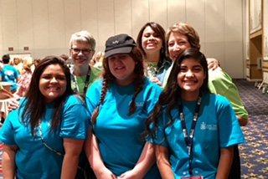
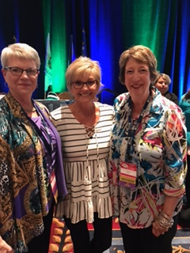
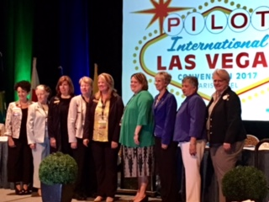
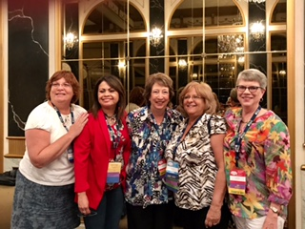
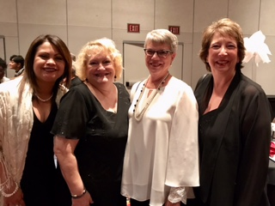

PROJECTS PLAN OF WORKS
Pilot Club of Odessa 2017 - 2018 Texas District
Coordinator – Karen Hopkins: 432-634-7437
Assistant Coordinator – Carrie Fambrough 432-413-1921
DIVISION MEMBERS:

Name | Phone # | Name | Phone #
Sheryl Jones | 512-971-6594 | Rhonda Gray | 432-296-2133
Lynn Van Amburgh | 432-553-6297 | Jackie Barnes/  Hazel Pace | 337-0403/  332-6059
LaNelle Agee | 432-559-7824 | Patty Williamson | 432-634-1141
Whitney Brady | 432-557-4310 | Kathy Schlegel | 432-631-8114
Sabrehna Everett | 432-352-0173 | Jean Gorrell | 432-312-3163
Bes Castleman | 432-553-2950 | Delores Veteto | 432-352-2939
Teresa Floyd | 432-528-2739 | Rebecca Williams | 432-257-6121

PROPOSED DIVISION ACTIVITIES:

Project | Facilitator(s) | Date | Budget
Friendship Home | Committee | annual | 500.00
Meals on Wheels | Committee | 3rd Fri of Mo. | $1500.00
Fall Festival and Hard Hats for Little Heads  *Bicycle event City of Odessa |  | Oct. 21 2017  Jan. 2018 | $3000.00  If we have extra
Brain Minders |  | annual | $150.00
Project Lifesaver | Lynn Van Amburgh | annual | $1500.00
Look Good/Feel Good | Committee | annual | $500.00
Texas TBI Camps | Committee |  | $500.00
Pick Me Up Bags |  | Nov/Dec | $500.00
PI 250 Club | - |  | $250.00
PI Ambassador | - |  | $25.00
PI Pacesetter Club | $10 x # members | July | $600.00
Benefit Veterans |  |  | $250.00 **
Walk | Teresa Floyd | Oct. 14, 2017 | $250.00
 |  | TOTAL | $9,525.00

MEMBERSHIP PLAN OF WORK
Pilot Club of Odessa 2017 - 2018 Texas District
Coordinator – Mary McClelland 108 Waimea, Odessa 79762
(432) 559-3068 macnblack@att.net
Assistant Coordinator – Sue Kettle 104 Waimea, Odessa 79762
(432) 559-7485 castironsue@gmail.com
DIVISION MEMBERS
Name | Phone # | Name | Phone #
Carla Bryant | 528-1815 | Anita Elms
Cheri Dalton | 352-3074 | Ann Volker | 557-4244
Debbie Donaldson | 413-9668
Suzan Gentry | 889-3272
Lee Anna Good | 934-6443
June Hoover | 385-4273
Lee Ann Johnson | 349-5807
Pat Johnson | 559-0063
Loretta Leslie | 348-8835
Susan Thornton | 553-2607
Jane Triplett | 254-9588

PROPOSED DIVISION ACTIVITIES:
Activity | Chairman | Date | Estimated  Expense | Estimated  Income | Budget Request
40 Year Anniversary  Celebration |  |  | 1,000.00 |  | 1,000.00
Brag Board |  |  | -0- |  | -0-
Brochures |  |  | 300.00 |  | 300.00
Cards & Flowers | Jane Triplett | Ongoing | 300.00 |  | 300.00
Chamber Ambassadors | Mary Blain | Ongoing | 50.00 |  | 50.00
Chamber Membership | n/a | n/a | 200.00 |  | 200.00
District Convention | n/a | April, 2018 | 2,000.00 |  | 2,000,00
Facebook Page | Mary McClelland | Ongoing | -0- |  | -0-
Fall Council | n/a | Sept., 2017 | 500.00 |  | 500.00
Misc./Supplies | n/a | n/a | 100.00 |  | 100.00
New Member Orientation | Carla Bryant |  | 200.00 |  | 200.00
Official Visit | n/a | TBA | 300.00 |  | 300.00
Past President’s Gift | Jannee Banner | June, 2018 | 100.00 |  | 100.00
PI Convention | n/a | 2017/2018 | 3,000.00 |  | 3,000.00
Poop Deck |  | Ongoing | 50.00 |  | 50.00
PO Box Rental | n/a | July, 2017 | 68.00 |  | 68.00
Postage | n/a | Ongoing | 49.00 |  | 49.00
Publicity | Susan Thornton | Ongoing | 50.00 |  | 50.00
Share Pilot | Pat Johnson/Debbie Donaldson |  | 200.00 |  | 200.00
Speakers’ Lunches | Ruben Rodriguez | Ongoing | 64.00 |  | 64.00
Stationery |  |  | -0- |  | -0-
Storage Unit Rental |  | Dec – June | 600.00 |  | 600.00
Treasurer’s Bond | Frances Irvine | July, 2017 | 100.00 |  | 100.00
Yearbook | Ann Volker | October, 2017 | 200.00 |  | 200.00
 |  | TOTAL | 9,431.00 |  | 9,431.00

A Look at the Future:
FUNDRAISING PLAN OF WORK

Pilot Club of Odessa 2017 - 2018 Texas District
Coordinator – Yolanda Sanchez
Assistant Coordinator – Omega Loera

DIVISION MEMBERS
Name | Phone # | Name | Phone #
Brenda Denton | 432-557-2206 | Barbara Benefield | 432-413-1399
Marjorie Garner | 432-349-0794 | Sandra Blaydes | 432-770-3678
Sherry Tuttle | 432-894-1481 | Glen Brown | 432-528-2783
Patty Austin |  | Adina Crain
Frances Irvine | 432-349-7640 | Carol Gregg | 432-368-4220
Beverly Landgraf | 432-638-5070 | Jaye Nabarrette
Ann Volker | 432-557-4244
Kathy Norwood | 432-528-0401

PROPOSED DIVISION ACTIVITIES:
Activity |  | Chairman |  | Date |  | Est. Expense |  | Est. Income |  | Budget Request
Garage Sale |  | Pat Johnson |  | Oct 14, 2017 |  | $200.00 |  | $4,200.00 |  | $200.00
 | Pecan Sales |  | Beverly Landgraf |  | Sept/Oct 2017 |  | $0 |  | $1,000.00 |  | $0
Consignment |  | Sherry Tuttle |  | All Year |  | 0 |  | $500.00 |  | $0
Gift Wrap |  | Stephanie Landgraf |  | Oct/Nov 2017 |  | $1,200.00 |  | $2,200.00 |  | $1,200.00
TOTAL OPERATING |  |  |  |  |  |  |  |  |  | $1,400.00
Community Christmas Tree |  | Lynn VanAmburgh |  | Nov/Dec 2017 |  | PBRC |  | PBRC |  | $0
Style Show |  | Brenda Denton, Chair  Jaye Nabarrette, Co-Chair |  | April 24, 2018 |  | $10,000.00 |  | $25,000.00 |  | $10,000.00
TOTAL PROJECTS |  |  |  |  |  | $11,400.00 |  | $32,900.00 |  | $11,400.00
Anchor Division
PLAN OF WORK

Pilot Club of Odessa 2017-2018 Texas District
Coordinator –LINDA PRUDEN 432-638-2961 4806 PEPPERIDGE Odessa, Tx
MARIA SANCHEZ 432-272-8331 8725W. Mars Odessa,Tx

DIVISION MEMBERS:

Name | Phone #
Carla Bryant | 432-528-1815
Huerta, Alma | 432-580-4768
Dianna Fields | 432-272-5791

PROPOSED DIVISION ACTIVITIES:

Activity | Chairman | Date | Est. Expense | Budget Request
Anchor Budget Addition |  |  |  | $475.00
Anchor Convention |  |  |  | $4,000.00
Jr. Leadership (3) |  |  |  | $525.00
Miscellaneous |  |  |  | $2,000.00
Total |  |  |  | $7,000.00

Leadership Division
PLAN OF WORK

Pilot Club of Odessa 2017-2018 Texas District
Coordinator – Jannee Banner 432-230-4337 Midland, TX

DIVISION MEMBERS:

Name | Phone #
Donna Ziriax

PROPOSED DIVISION ACTIVITIES:

Activity | Chairman | Date | Est. Expense | Budget Request
Misc/Training supplies |  |  |  | $50.00
Leadership Odessa |  |  |  | $300.00
Total |  |  |  | $350.00

