Texas Traumatic Brain Injury Camps –2017
TX Pilot TBI Camp, Inc. (501(c) (3) foundation for Texas District Pilot & Anchor Clubs
www.TexasPilotTBICamps.org pitexasdistrict.org



Mountain High (Est. 8-1994) Aug. 26 – 30, 2018 Red River, New Mexico, 5 days 4 nights Sponsored by Mountain High Foundation, Baylor Rehab of Dallas, Faith Mountain Fellowship Church, Red River and Texas District Pilot & Anchor Clubs. A camp for TBI adult survivors. Fees are $250 for camp which includes meals, lodging and all activities plus $450 for airfare from Dallas or $450 airfare from Houston or Austin. www.moutainhighcamp.com Serving 80 Survivors & 150 volunteers & family members.


Circle of Friends (Est.11-2000) Nov. 2 - 4, 2018 Camp Shiloh, Lake Bob Sandlin, near Mt. Pleasant Texas. 3 Days, 2 Nights Sponsors - Texas District Pilots & Anchor Clubs. A camp for adult TBI survivors. $50.00 per person for overnights and $20.00 per person for daytime including camp tee shirt. www.campshilohretreat.org Serving 50 Survivors & 75 volunteers & family members.

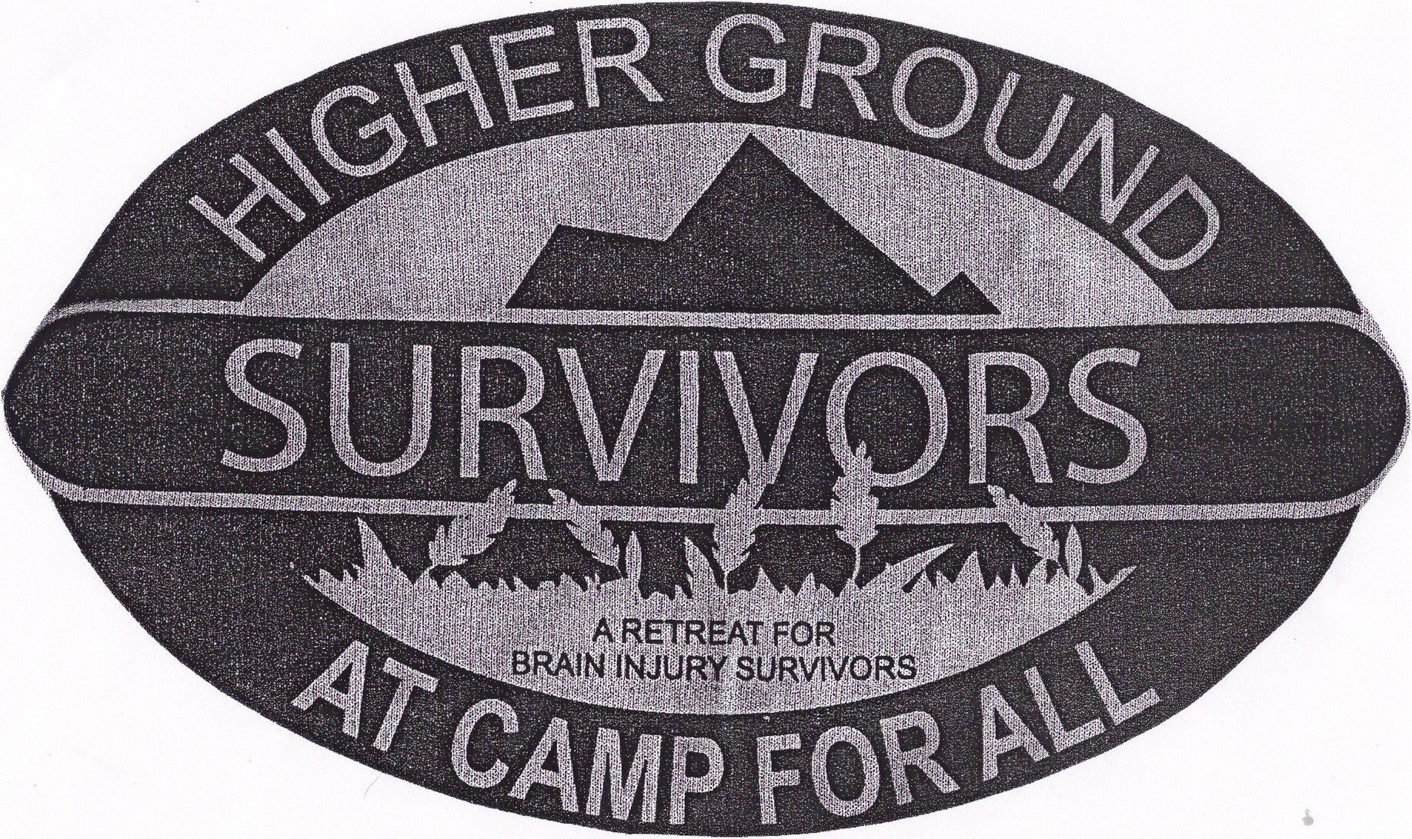
Higher Ground (Est. 10-1997) May 3 - 6, 2018 Camp For All near Burton, Texas.
4 days 3 nights or 3 days 2 nights. Sponsored by Texas District Pilot & Anchor Clubs.
A camp for TBI adult survivors. $25 daytime including tee shirt & meal. 4 Days 3 Nights $243.00 per person 3 Days 2 Nights $162.00 per person Cabin Lodging $81 per night Retreat Center (Call for info & availability). ($102/$204/$306) www.campforall.org Serving 125 Survivors & 125 Volunteers & family members.

Important – Scholarships are available for all camps.

TEXAS CAMP FOUNDATION INFORMATION: TX Pilot TBI Camp, Inc.
501(c)(3) Foundation for Texas District Pilot Clubs and TBI Camps
% Joanna Horton, President, P O Box 732, Winnsboro, TX 75494
AND/OR Janell Abbott, Treasurer, 212 Lakeside Place, Mineola, TX 75773

Mountain High: www.mountainhighcamp.com
Charlotte Wilson, PO Box 467, Winnsboro, TX 75494
mthigh@hotmail.com 903-629-3748

Higher Ground: www.campforall.org
Joanna Horton, PO Box 732, Winnsboro, TX 75494
joanna@nabors-horton.com 903-342-5555/903-342-5026
Leah Hight, 1405 North Cleveland, Dayton, TX 77535
lllhight@yahoo.com 936-258-2409
Lori An Gobert, 1402 Front St., Columbus, TX 78934
lagobert@sbcglobal.net

Circle of Friends: www.campshilohretreat.org
Joanna Horton, PO Box 732, Winnsboro, TX 75494
joanna@nabors-horton.com
Joyce Curry, PO Box 3, Mineola, TX 75773
curry@lcairwaves.com
Betty Reese, 2725 Sleepy Hollow, Mt Pleasant, TX 75455
granniebet@gmail.com

Oklahoma TBI Camp, April 2018
Tracy Grammer, 1141 Barbary Dr. Norman, OK 73072 tgrammerslp@Yahoo.com

Friends of Hope – March and October; Sponsored by Baylor Rehab Dallas
Samantha.cleveland@baylorhealth.edu

Louisiana Camp Fleur de Lis, March 10-12, 2017 Lions Club Camp, Leesville, LA

Alabama TBI Camp, April 2017, Camp ASCCA Easter Seals, Jackson Gap, AL.

Texas District Pilot Clubs – Annual Fund Raiser - $100 Club
Be a $100 Club Member (individually) and/or be a $100 Pilot Club, (or be both) Est 2013.
Send your $100 check to: TX TBI Camp, Inc. Joanna Horton, P O Box 732, Winnsboro TX 75494

