***Texas District Pilot International***

***Fall Council***



Good morning (or afternoon)! Most of you recall last year we were busy riding the energy bus and this year we are thinking “Let’s walk and talk Pilot” and we are pleased to present to you:

***“Putting your best foot forward by using***

***Ten Characteristics of Effective Teams”***



Connie Moore, Pilot International President presented Ten Characteristics of Effective Teams to the Council of Leaders at PI convention held in Montreal, Canada and we would like to share her presentation with you. We are going to go through each of the Ten Characteristics and how each one can apply to you as a Pilot club member.



1. The **Purpose** or reason for the Team’s existence is clear.

Our purpose is governed by our refined mission statement which is:

* **The mission of Pilot International is**: to influence positive change in communities throughout the world.
* **To do this, we:** come together in friendship and give people an outlet for service.
* **We focus on:** 
  + Preparing youth and young adults for service
  + Encouraging brain safety and health
  + Supporting those who care for others.



1. **Priorities** or the order of what needs to be done by Team is clear.

Set your goals of what you would like to accomplish during year. Then you will need to work backwards from your goal to determine what you need to do first on the way to accomplishing your goal.



1. **Roles, or the** positions Team members hold **are clearly defined.**

What is your part of the Team and what is expected of you? If you have any questions about you duties please look at our club manual on our website which is [www.pilotinternational.org](http://www.pilotinternational.org)



1. **Decisions** are made by consensus or following parliamentary procedure.

Everyone has a voice. Be willing to listen to other positions and always remember that majority rules.



1. **Conflict** must be dealt with quickly and openly in a healthy Team.

Deal with conflict and resolve the problem as it arises. Remember to praise in public but address issues in private.

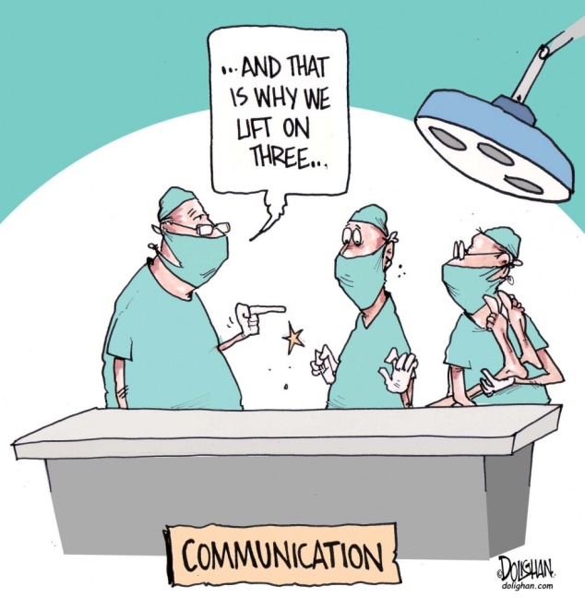

1. **Communication** must be open and members need to ask questions to clarify their understanding.

Everyone must have access to the same information and communication is key to everyone being on the same page. Presidents please remember to forward to your members the Governor’s bulletins along with any other information from the Governor. That way we can help to keep all members well informed.



1. The **Climate** is warm, open and fun!

The Team must have a welcoming atmosphere and be inclusive of everyone.

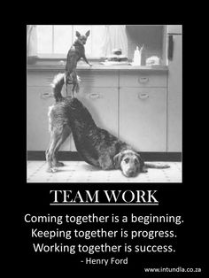

1. The **Personal Traits** of individual members are well utilized.

Use each person’s strengths and their area of expertise.

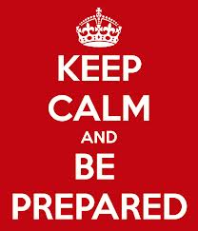

1. **Leadership** is always well informed and prepared.

Be prepared and know your information or where to find it! A great place to find that needed information is the new Smart Book which is available on the Pilot International website.



1. **Participation and Involvement** is needed by all Team members.

Every Team member must contribute and be an active member of the Team.

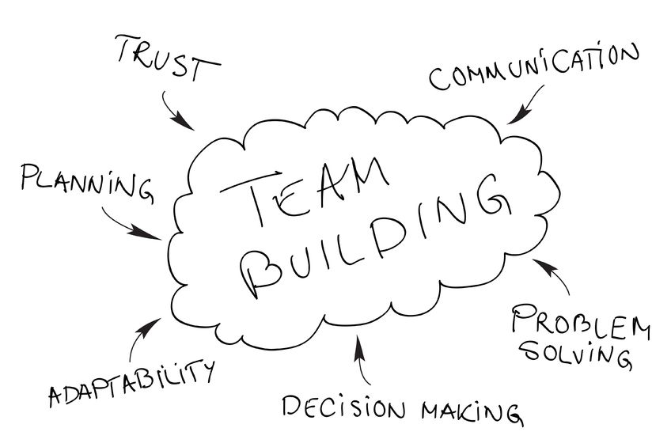

**Remember:**

**The foundation of any effectively functioning team is TRUST. Trust takes time, effort and attention to build…but can be eroded quickly with a single action.**

**Be mindful of cultivating positive relationships that build trust through open communication.**

What is team building? According to one scholar team building is the process of **forming, growing**, and improving the **knowledge, skills** and **attitudes** of individuals with different needs, **backgrounds** and **abilities** into an integrated, high- performance team.

The second part of the Team Building presentation is to recognize each team member’s own strengths and weaknesses with this questionnaire. The statements were based on a Team Building Exercise presentation at PI Convention in Montreal given by Laura Keever, 2000-2001 PI President.



***“Put your best foot forward by***

***finding your spot on your Team”***

* We will pass out pens with the questionnaire, keep the paper face down until instructions are given and you are directed to turn the paper over.

The questionnaire consists of nine statements. The group will be given time to rate each statement by giving it a number:

1 (**strongly disagree**) to 10 (**strongly agree**)

For example:

If there was a statement that said “I am good at eating chocolate” Gail, Diane and I would rate it as a 10.

After the group is done filling out the questionairre, go over each statement and read to the group what is written in italics.

* _____ I am good at paying attention to detail.

*Some ways to improve in this area is to try some of the following:*

* + - 1. *Get organized*
      2. *Make lists*
      3. *Keep a schedule*
      4. *Limit distractions*
      5. *Don’t multitask*

*Don’t forget sometimes paying attention to details includes looking at a person’s body language or listening to their tone of voice.*

* _____ I am flexible and willing to change.

*A few examples of flexibility are:*

1. *Adapting successfully to changing situations*
2. *Having alternative options in case things go wrong*
3. *Taking on new challenges at short notice.*

* _____ I am willing to experiment.

*Maybe try something for a short period of time as opposed to forever. Be persistent. There will always be setbacks and obstacles in life. Don’t stick to your old way of doing and seeing things.*

* _____ I embrace my imperfections.

*Be accepting of your shortcomings. There is no need to be perfect to inspire others. Let others get inspired by how you deal with your imperfections.*

* _____ I take things one step at a time.

*Slow down, take one thing at a time maybe start with a difficult task then the rest of the tasks will be easier. Breathe in, breathe out and remember that moving forward means taking it one step at a time.*

* _____ I am constantly learning.

*Check into self-help books, articles or read about something out of your comfort zone. There is no such thing as failure if you are constantly gaining knowledge or skill by study, experience or being taught.*

* _____ I write down and track my goals.

*Keep track of the progress on achieving your goals. You may want to reward yourself along the way to your success.*

*The following is a quote from writer and novelist Michael Korda:*

*Write it down.*

*Written goals have a way of transforming wishes into WANTS,*

*Can’ts into CANs,*

*Dreams into PLANS,*

*And plans into REALITY.*

*Don’t just think it – INK it!*

* _____ I am encouraging and positive.

*Encourage your team members and always be confident and project an upbeat attitude.*

*This is from a motivational writer;*

*“Always be generous with your encouraging words, you may find they will inspire others to be the best they can be.”*

* _____ I always find the fun in our activities.

*Try to put some fun in with your team or project. In our club meeting we have a brag time so you can learn the fun things happening to your members. What could you do differently at your meeting or project that would make it more fun?*

*Remember what Mary Poppins said “In every job that must be done there is an element of FUN!”*

Please look at your paper and find statements that you rated an 8 or above – these are the areas that you are already an asset to your team. Now look at statements that you rated less than 5 – these are the areas in which you might want to look for opportunities to build your skill. You already bring a variety of talents to your club. You might like to challenge yourself by improving in one area this year. Think about your place on your team and what you can do to improve yourself which will, in turn, improve your team.

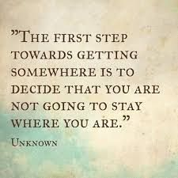

**Remember:**

**Build on your strengths and work on your weakness for the success of your team.**

**We are all on the same team so let’s put our best foot forward as we…**



**Let’s Walk and Talk Pilot**