Granville K-Kids 2016-2017 Year in Review
June:
- Met with Kiwanis president, Kiwanis Lieutenant Governor, K-Kids advisor from another school to brainstorm ideas and plan for the year
August:
- Introduced Granville K-Kids to parents at parent curriculum night
- Distributed Intent to Participate paperwork to all students

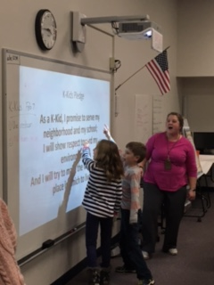
September:
- Charter event member induction and kick-off celebration with community officials (Mayor, Granville Fire Department Chief, Granville Police Department Sergeant, Kiwanis President, Kiwanis Lt. Governor, GES Assistant Principal)
- Community and school needs boards to identify service projects in our community and school (gallery walk, in small groups)
- Made posters for school and community, positive reinforcement of positive behaviors
October:
- Introduced Buddy Bench as a yearlong project
- K-Kids Executive Board decided basic requirements for Buddy Bench after consulting with members and gathering input
- Made bookmarks for the new Kiwanis Club of the Polaris Area in support of the Governor Flinta’s literacy project theme
- Assisted with the Granville Kiwanis Maple Leaf 5K along with parents, Kiwanians, and Key Club. Distributed water, created inspirational signs, cheered on participants
November:
- Veteran’s Day – program by Kiwanian and Navy Veteran Dr. Boldon (shared his experiences and artifacts, Q and A with K-Kids)
  - Interested K-Kids member attended Kiwanis meeting with WWII veteran, Don Jakeway
- Wrote letters to veterans – mailed to Licking County Veterans Commission
- Planted daffodil bulbs in front school parking area to create a Veteran’s Memorial in honor of our veterans
- Made food drive signs for school Thanksgiving food drive and posted around the building in conjunction with intermediate school student council
- Selected Buddy Bench (voted on two choices of reconditioned benches, to be donated by Granville Kiwanis), with help from Builder’s Club member
- Decorated cards for to be included with bagged food drive items
- Made plans for recess safety videos as requested by school principal
December: 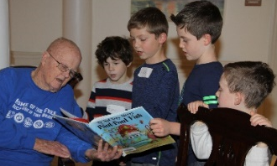
- Prepared holiday bingo cards to take to senior living facility
- Planted maple tree with Kiwanis club on school property; dedicated the tree Granville K-Kids 2017 Club, also buried time capsule beneath tree with names of members and memorabilia from 2017 (penny) including a list of fuel, milk, etc. prices and popular toys and songs with kids
- Field trip to Middleton Senior Living Center to read holiday stories and play bingo. Transportation funded by Granville Kiwanis Club
January:
- Three K-Kids members and advisor attended Kiwanis club meeting to present about K-Kids service projects with other Kiwanis family student leadership programs (SLPs) including Key Club and Builder’s Club for “SLP Night”
- Made birdfeeders from pine cones with peanut butter, honey and covered in seeds, and also Cheerio birdfeeders; hung in trees around school (warm enough to do this outside in January!). Played an outdoor tag game.
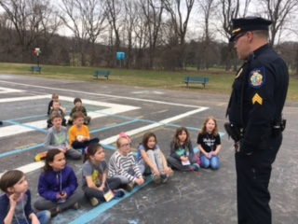
- Made posters for K-Kids contest “Best Poster for a Cause”
February:
- Made Valentine cards for seniors at Middleton and Kendal senior living facilities
- Collected books to give away at Kiwanis Pancake Day Fundraiser for Wildwood Park and Playground
- Created murals with wooden sticks of Wildwood park for GRD to use during the pancake fundraiser for the Wildwood Park renovations in spring 2018
- K-Kids and parents volunteered at pancake fundraiser, overseeing the coloring station and book giveaway in conjunction with Read for 20
- Shared experiences from Pancake Day service project (literacy/book donation with Licking County Reading Foundation) and coloring table at K-Kids meeting
- Created handprints on aprons to be given to the Governor and Lt. Governor at the Midyear Conference (where advisor presented a session about K-Kids and children’s service based learning). Apron represented “K-Kids Hands on Service” and tied in with the Kiwanis Pancake Days.
- Made giant hearts of painted handprints to display in school staff/teacher’s lounge and given to Granville Kiwanis for Valentine’s Day
- Sergeant King from Granville Police Department came to discuss safety (outside on playground)
- Made playground safety videos per request of GES principal. Advisor edited and showed at next meeting. They were shared with principal (and teachers) and will be used to educate students next year. Videos were taped by Granville Kiwanis volunteers
- Picked up trash around playground and school grounds
March:
- National Read across America Day, SkippyJon Jones and Mama Bernstein Bear (costumes worn by Kiwanis members) visited the school for lunch (2nd and 3rd graders). Skippy Jon Jones was read aloud/displayed on the projector
- Speaker/program by Nancy Gregory from Dawes Arboretum about making maple syrup. Educational and hands on, tied in with Kiwanis syrup making project
- Made thank you notes to Sergeant King (for safety discussion)
- Seed planting with middle school FCCLA club (fruit and vegetable seeds for GES school garden)
- Made “Caution: Daffodils in bloom!” signs to post in Veteran’s memorial garden as they sprouted since they were in between a walkway and parking lot
- Took down the empty pine cone birdfeeders
- Made thank you cards for Mrs. Gregory
April:
- Shared ideas and voted on initial design ideas for Buddy Bench
- Made more aprons with handprints for friends and volunteers
- Prepped Buddy Bench – traced handprints
- Collaborated with GHS Film Club to make a video about our Buddy Bench
- Voted on Bench color with stickers and discussed voting at meetings (random lists with check marks (duplicate votes) versus specific limited choices and one vote per person (equal representation))
- Discussed ideas for Earth Day programs (trees, recycling, environment) in committees and made top three list
- Earth Day recycling education and hands on activities with Kiwanis member and recycling consultant
- Earth Day recycling and reusing of pallets for mulch and repurposing buddy bench with Hope Timber Garden Center
- Bundling of maple seedlings for GES to distribute to students
May:
- Transplanted fruit and vegetable seedlings to GES school garden with GMS FCCLA club. Produce will be a part of school lunches in the fall
- Planted flowers in tins for Aktion Club to sell for Mother’s Day fundraiser
- Six Mother’s Day potted flowers delivered to local senior citizens by K-Kids members and parents
- Assembled bags of chocolates for GES staff during Staff Appreciation Week
- End of the Year Celebration
  - Ribbon Cutting with district administrators and parents to commemorate and install our signature project Buddy Bench
  - Celebrated our accomplishments by sharing SnoCones with families of K-Kids members. SnoCones and watermelon provided by Granville Kiwanis
  - Implementation of our GES Buddy Bench
  - Honor our volunteers and recognize K-Kids Year service accomplishments
- Surveyed parents and K-Kids members to gather feedback for future planning
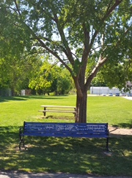
June:
- Designed and decorate Kiwanis K-Kids parade float at weekly Kiwanis meeting (K-Kids members, parents, Kiwanians)
July:
- Fourth of July Parade – K-Kids rode on float, walked alongside float with parents and Kiwanians, passed out candy

