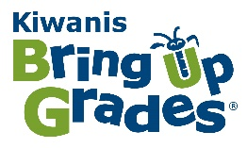
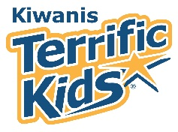
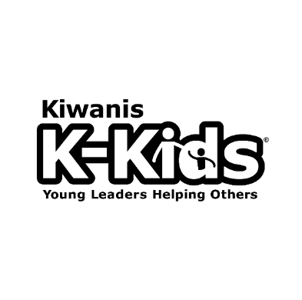

Kiwanis Kids – a student-led community service club for elementary students age 5-12.
Sites - Traditional schools, Home schools, After-school programs, Community-based programs
KiwanisKids.org – for resources and tools to start and support a K-Kids club
What is Kiwanis Kids? K-Kids is a service leadership club for elementary schools students sponsored by a Kiwanis club, co-sponsored by Key Club or Circle K. Fifteen or more students meet weekly or bi-weekly to conduct club meetings with the support of a Kiwanis club advisor. Members elect officers, identify community needs, plan service and fundraising projects, and develop leadership skills. Club meetings can be scheduled during lunch, recess or after school.
What is Terrific Kids? Terrific Kids is a character-development program that focuses on learning leadership by establishing and achieving goals connected to character traits. Participants are actively involved in setting and achieving goals, so they’re engaged. Students compete against their own personal best, not others. They learn to persevere and when confronted with failure, to reflect, adjust and try again.
What is Bring Up Grades? Bring Up Grades is an academic-achievement program that focuses on establishing a goal to improve in one subject, while maintaining other grades. Participants are actively involved in identifying which area of study needs attention.
Cost: Initial charter fee for K-Kids club ($180-$300). Annual renewal fee ($180) paid by sponsoring Kiwanis Club; Kiwanis Secretary sees invoice on online reporting system. Program kits for Terrific Kids and Bring Up Grades available at Kiwanis Store ($115 each).
*Kiwanis Club Secretary - To ensure active clubs receive enough materials and updates, the sponsoring Kiwanis club secretaries must update the club’s membership count, Faculty advisor and mailing address by August 31 in the Kiwanis Online Reporting System. An invoice for the club’s renewal fee appears after October 1 on the finance tab of the secretary dashboard.
Monthly reporting – The Kiwanis Advisor reports the K-Kids club’s service and fundraising activities on monthly reports in the Kiwanis Online Reporting System.
Contests and Awards - submitted online and due on December 15 and May 1, each year.
Club Presidents and Advisors – Start a club. Host an SLP Rally or program for SLP clubs to share their service projects. forum should allow members and parents to interact, share ideas and plan projects. Invite K-Kids and their parents to lead meeting and participate in your projects. Promote the K-Kids’ service activities to your club, community, Division, District and KI. Recognize student leaders and advisors for outstanding service and awards.
The Faculty and Kiwanis Advisors are vital contributors to the shared work of achieving our vision and mission. They are our program’s most important volunteers because they plant the seeds of hope, learning and service in the minds of our members. They help connect the club to Kiwanis International, create good experiences for members, and most importantly, change lives. Completing K-Kids monthly reports online by the 10th of the next month helps.
SLP Stats: As of March 12, 2018, there are 66 Kiwanis Kids (K-Kids), 89 Builders Clubs and 215+ active Key Clubs in the Ohio District. As you can see, we have opportunity to grow!

Jennifer Lewis, K-Kids Ohio District Administrator, (740) 485-2040, Lewis.792@osu.edu

