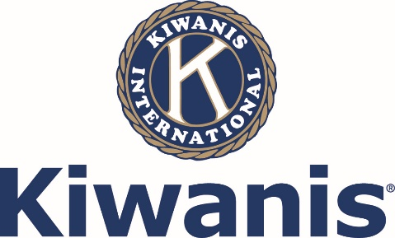
99th Alabama District Convention Kiwanis International Aug 18-20, 2017
Hosted by the Kiwanis Club of Auburn The Hotel at Auburn University
Name: Last: | First:
Address:
City:
Phone:
Email:
Club: Division: Club Officer? If so, what office?
Name of Guest(s):

Events | Number(s) | Cost | Total
Registration |  | $135
(Please register by July 31)
Friday Night Dinner (August 18) |  | included
Guest(s) for Friday Night Dinner |  | $37
Saturday Breakfast Buffet (August 19-RIF, Governor, Lt Governor) |  | $25
Interclub Luncheon |  | Included
Guest(s) for Interclub Luncheon |  | $37
Saturday Evening Governor’s Dinner |  | $55
Sunday Non-Denomination Prayer Breakfast Buffet (August 20) |  | $25
Total
Make checks payable to the Kiwanis Club of Auburn and mail to P.O. Box 1982, Auburn, AL 36831. Want to pay online using a credit card? Secure, online registration available on District Website. alabama.kiwanis.org
Hotel Group Rate: Reserve your room directly through The Hotel at Auburn University by July 31 to receive a conference discount. Rate Code: Kiwanis $132
The Hotel at Auburn University, 241 South College Street, Auburn, AL 36830 (334) 821-8200
https://gc.synxis.com/?Hotel=75989&Group=170727KIWA&arrive=08/17/2017
Important: Persons attending the Interclub Luncheon must check in at the registration table at least 30 minutes prior to the start of the luncheon or forfeit their reservation.
Questions? Contact Mary Hoerlein Prather, 334-744-0009 or prathmh@auburn.edu

