Iredell County Agricultural Fair
(Owned and Operated by The Kiwanis Club of Statesville)
P.O. Box 1434 Statesville, NC 28687
www.iredellcountyfair.com

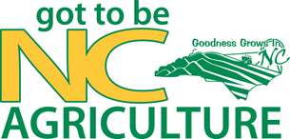

VENDOR APPLICATION
• Food Vendors are to Call Jim Head at 704-880-6948
• NC Sales Tax Number Required (New Law)
• Check must accompany application
• Space Only
• Set-Up Times Thursday, September 2 from 12 Noon until 8PM
Friday, September 3 from 8AM until 12 Noon
Inside Booths 10’ x 10’ $ 150
10’ x 20’ $ 250
Outside Booth 10’ x 10’ $ 250
10’ x 20’ $ 400
Company Name: ____________________________________
Person Responsible: ____________________________________
Address: ____________________________________
____________________________________
Phone #: __________NC Sales Tax No_____________
Product or Service: ____________________________________

Return Application with Check to: Iredell County Agricultural Fair
P. O. Box 1434
Statesville, NC 28687
Or call Jim Head at 704-872-4032

