WELCOME BACK DINNER and KIWANIANNE MEMBERSHIP MEETING
WEDNESDAY, September 6, 2017, 5:30 p.m.
At Rubel Castle
5:30 Welcome and
social time
6:00 Tour of the Tin Palace
6:30 Dinner
6:45 General Meeting
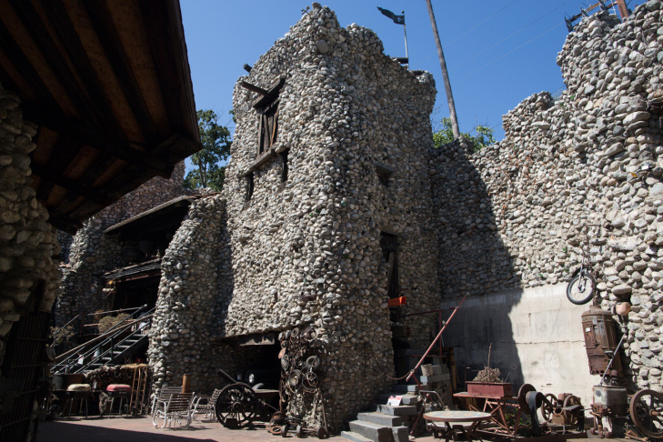
Bring one potential member to this fun meeting (or spouse, significant other, family member) and enjoy the fun! Jim Reilly will lead a tour of the “Tin Palace” inside the castle and then we’ll enjoy a wonderful meal of: tri tip, beans, salad, dessert, ice tea, water. Our meeting will follow the tour and dinner. Please plan to attend.
COST IS: $20 PER PERSON
Please make checks payable to: The Glendora Kiwaniannes
And mail them to Pat Rasmussen – 270 Oakland Road, Glendora, CA 91741 by NO LATER THAN: August 30.
Please help us recruit new members and bring one guest to this fun meeting!
Rubel Castle is located at: 844 N. Live Oak Avenue, Glendora. Street parking.
- - - - - - - - - - - - - - - - - - - - - - - - - - - - - - - - - - - - - - - - - - - - - - - - - - - - - - - - - - - - - - - - - -

Your name _______________________________ Guest’s name______________________
Number of dinners at $20 each _______ Total enclosed: ___________________________
Deadline to make your reservation for dinner is August 30. Event is Wednesday, September 6, 5:30 p.m. Mail your check to Pat Rasmussen.

