FLAG AGREEMENT/RENEWAL
THIS AGREEMENT is made this____ day of_______ , 20___, between Kiwanis of Nashville Foundation (“Kiwanis”) and ______________________________________________________ (“Customer”) for the placement of a flag at ______________________________________________________ (“Location”) _______________ (“Phone”).

Signature email Date
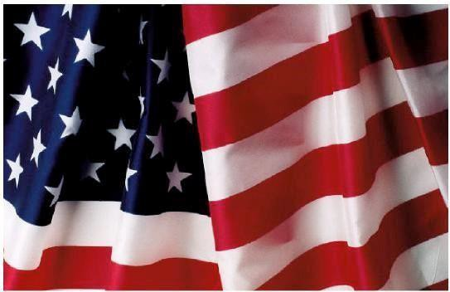
- For the sum of Fifty Dollars ($50.00), which is to be paid upon execution of this Agreement by Customer, Kiwanis agrees to place a 3’x 5’ American Flag, pole and mounting bracket or stand at the Location on the following days for the year 2018.
Memorial Day Flag Day
Independence Day Labor Day
Patriots Day Veterans Day
- A mounting bracket or some other holding device will be necessary for the placement of the pole and flag. Kiwanis and Customer will endeavor to agree as to either the method of attachment to the building or placement in the yard. In the event that there is no Agreement, then either Customer or Kiwanis may cancel this Agreement. It is agreed that once a location has been determined for the placement of the bracket or other holding device, Kiwanis has the right to utilize that bracket or holding device for the remaining times that the flag is displayed at Customer’s Location.
- Kiwanis agrees that at least one day prior to each of the above days it will place the flag and pole at the Location and it shall remain there until removed by Kiwanis within one week with the exception of Labor Day when it will remain in place through Patriots Day.
- Kiwanis and Customer acknowledge the possibility of winds or other natural occurrences that could cause the flag and/or pole to be blown down, causing damage to property or persons. Both also agree that the attachment of the bracket or holding device causes an alteration and/or damage to the building or grounds where it is attached. Customer does hereby release Kiwanis of and from any and all liability of any kind or nature, resulting or arising from the installation or flying of the flag, including resultant damage of all kinds to persons or property should the bracket, installation, pole or other device associated with the flag fail or be destroyed. In any event, the limit of liability of Kiwanis shall be the contract price of this Agreement.
- It is agreed that Kiwanis can cancel this Agreement at any time. In the event the Agreement is canceled, Customer shall be entitled to a refund of the fee paid hereunder, based on a prorated distribution. E.g, if the flag has been displayed for two of the seven holidays, then the customer would be entitled to a refund of $8.00 per day that the flag was not flown.
*Additionally, if Customer signs on with only one or two of the designated days left in the calendar year, your contract will begin January 1 of the following year and we will collect an additional $5.00 per remaining designated days in the current year.
- Customer shall not be liable for any damage to the flag unless it was caused by the Customer’s own negligence or intentional act or any person acting under or in the control of or related to the customer.
Please MAIL completed flag agreement with your payment by check or
credit card information to:

Kiwanis of Nashville Foundation
P.O. Box 22908
Nashville, TN 37202-2908

