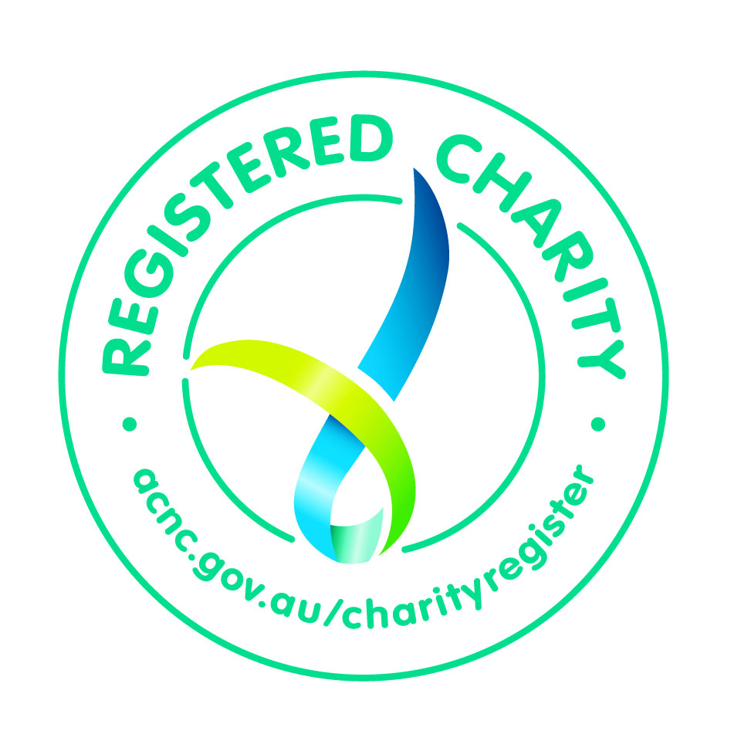

NOMINATION FORM
This unique Australian and prestigious recognition award is available for exceptional services to Kiwanis and/or community by Kiwanis members or non-Kiwanis individuals, businesses or community leaders. Must be bestowed upon recipient by another person, Kiwanis Club or District.
Each recipient of the Rising Sun Honour will receive an engraved award and personalised certificate.
Please complete this NOMINATION FORM and forward to:
Secretary, Kiwanis Australia District Charitable Foundation, 4 Atherton Close, Aspendale Gardens, Vic 3195

Donor Information |  |  | Kiwanis District or Club |  |  |  |  | Individual |  |  |  | Corporate or Business
Kiwanis District or Club Name |  |  |  |  |  | Corporate or Business Name
Contact First Name |  |  |  |  |  | Surname
Postal Address
City |  |  |  | State |  |  | Postcode |  |  |  | Country
Email |  |  |  |  |  |  |  |  | Phone Number

Mailing Address for Award and Certificate as above other as below

Address
City |  |  | State |  |  |  |  |  | Postcode |  |  |  |  | Country
Presentation Date
Recipient Information
Recipient Name for Award and Certificate
Name of Kiwanis District or Club
First Name |  |  |  |  |  |  |  | Surname
Postal Address
City |  |  | State |  |  |  |  |  | Postcode |  |  |  | Country
Email |  |  |  |  |  |  |  |  |  | Phone Number
Payment Method Options
Donors are requested to mail the Nomination Form to the Foundation AND Donate after selecting choice of online payment options using the link on the web page Donate Now

Kiwanis Australia District Charitable Foundation (ABN 68 395 086 292)
Secretary, 4 Atherton Close, Aspendale Gardens Vic 3195
Kiwanis Australia District Inc (Reg. No. A0043731 W)

